-22AIE442- **Robotic operating systems and robotic simulations**

# **Labsheet – 5**



1. **Prerequisites**

Gazebo plugins are essential for extending the functionalities of the Gazebo simulation environment, enabling control over various aspects of the simulation, such as the world environment, model behaviours, sensors, system parameters, and user interface. The different types of Gazebo plugins available: World, Model, Sensor, System, Visual, and GUI.

$ sudo apt install ros-noetic-gazebo-plugins

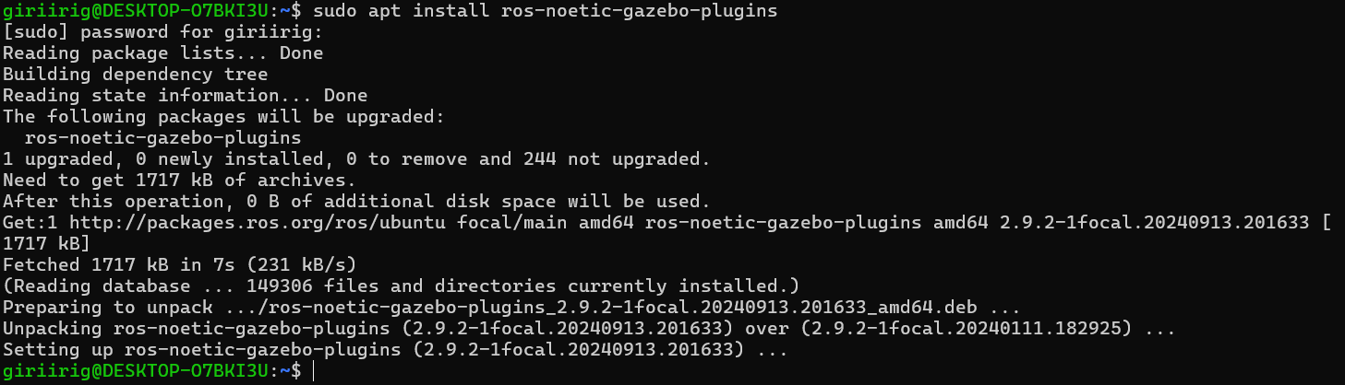

$ mkdir -p ~/GazeboPluginLab  
$ cd ~/GazeboPluginLab  
$ mkdir -p WorldPlugin/build  
$ mkdir -p ModelPlugin/build  
$ mkdir -p SensorPlugin/build  
$ mkdir -p SystemPlugin/build  
$ mkdir -p VisualPlugin/build  
$ mkdir -p GUIPlugin/build  
$ mkdir sdf

$ export GAZEBO_PLUGIN_PATH=~/GazeboPluginLab/WorldPlugin/build:~/GazeboPluginLab/ModelPlugin/build:~/GazeboPluginLab/SensorPlugin/build:~/GazeboPluginLab/SystemPlugin/build:~/GazeboPluginLab/VisualPlugin/build:~/GazeboPluginLab/GUIPlugin/build

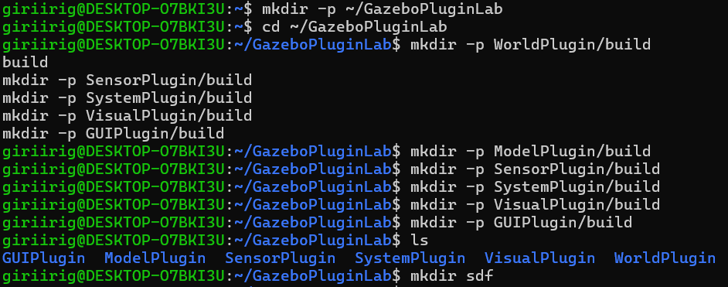

1. **World Plugin**

World plugins control properties and behaviours across the entire simulation world. They can adjust environmental factors such as gravity, lighting, and atmosphere.

$ cd ~/GazeboPluginLab/WorldPlugin  
$ nano WorldPluginExample.cpp

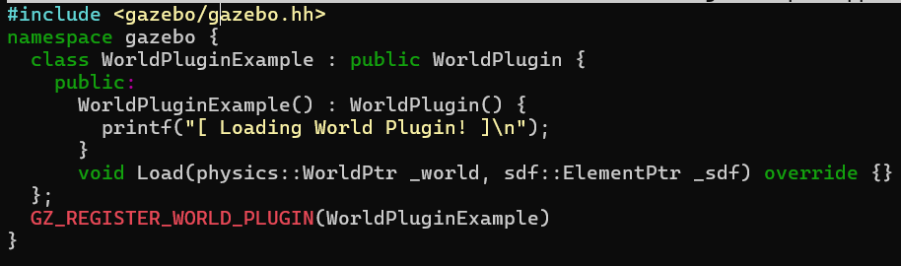

$ nano ***CMakeLists.txt***

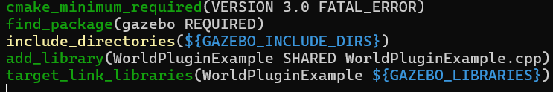

$ cd build  
$ cmake ..  
$ make

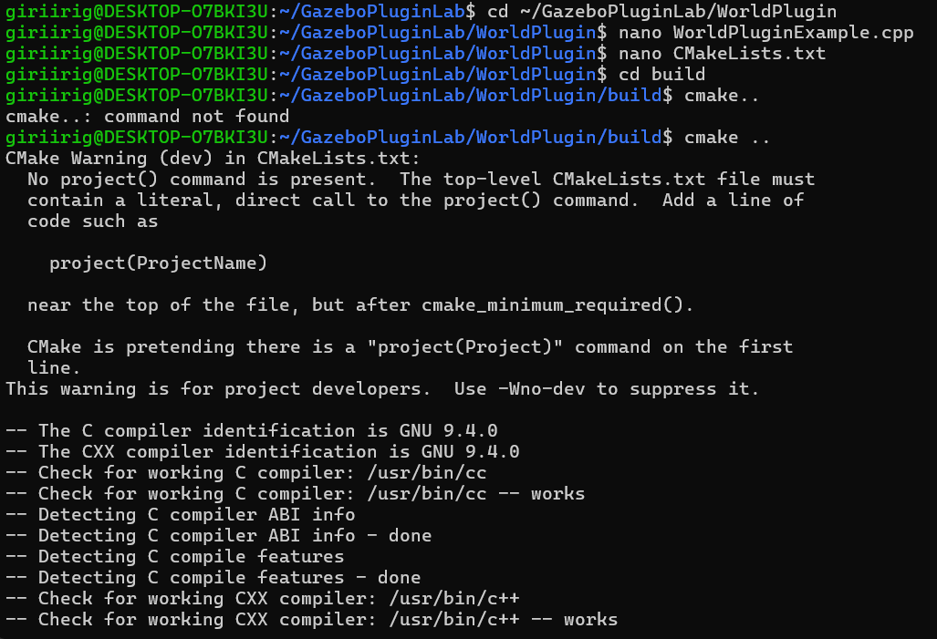$ ***cd ~/GazeboPluginLab/sdf***  
$ nano ***world_plugin_test.world***

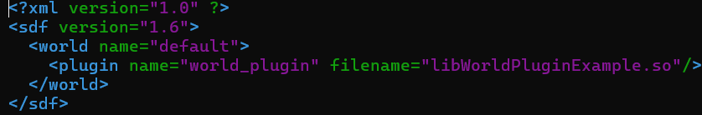  
$ gazebo ~/GazeboPluginLab/sdf/world_plugin_test.world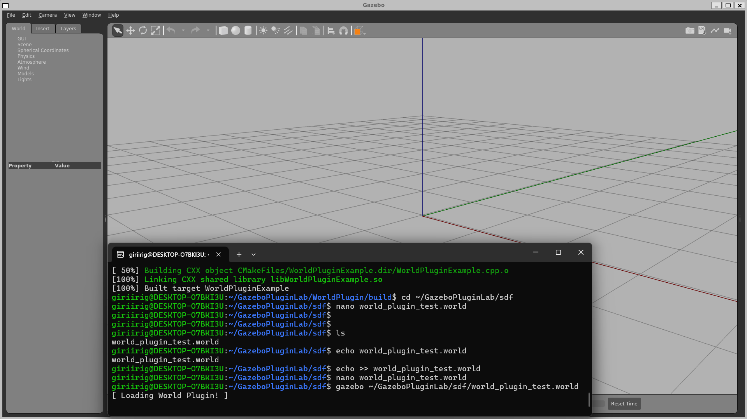

1. **Model Plugin**

Model plugins allow control and customization of individual models (e.g., robots, objects) within the simulation. They enable direct manipulation of model behaviours, such as applying forces, controlling joints, managing state changes, position, velocity, and behaviour.

$ cd ~/GazeboPluginLab/ModelPlugin  
$ nano ModelPluginExample.cpp

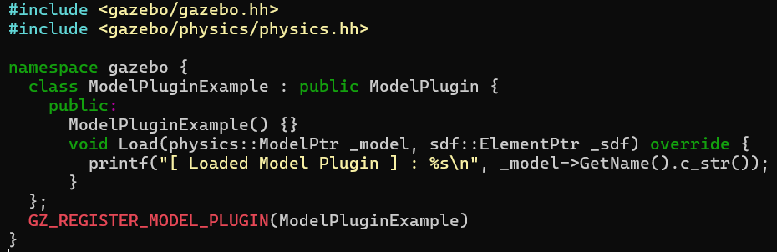

$ nano CMakeLists.txt

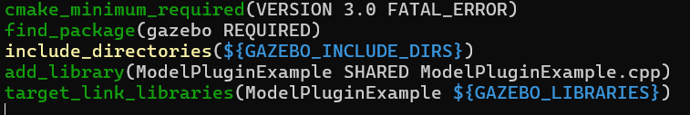

$ cd build  
$ cmake ..  
$ make  
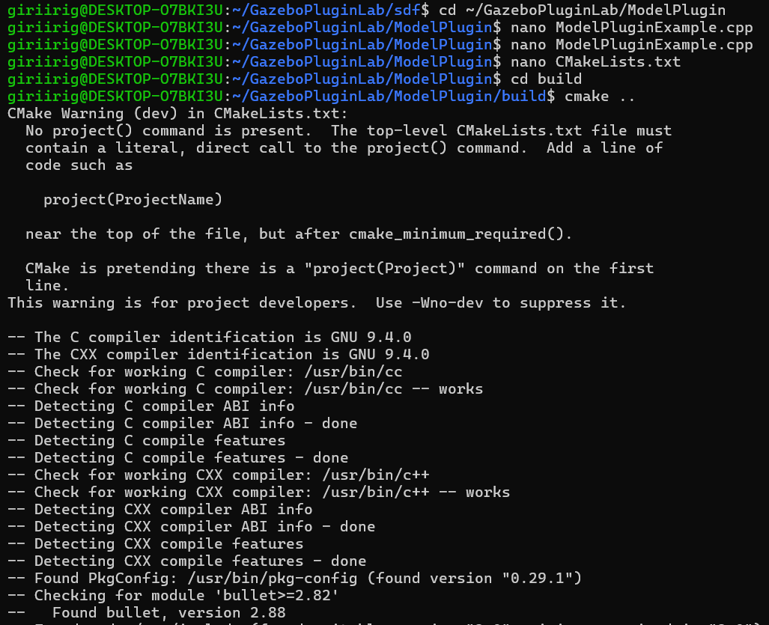

$ ***cd ~/GazeboPluginLab/sdf  
$ nano model_plugin_test.sdf***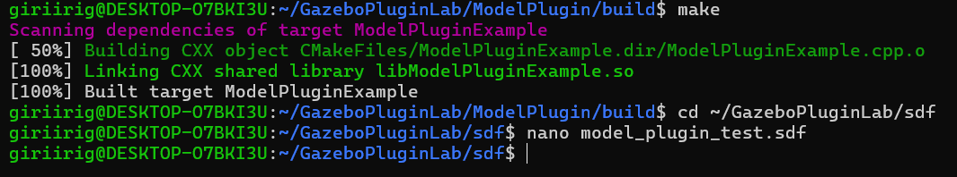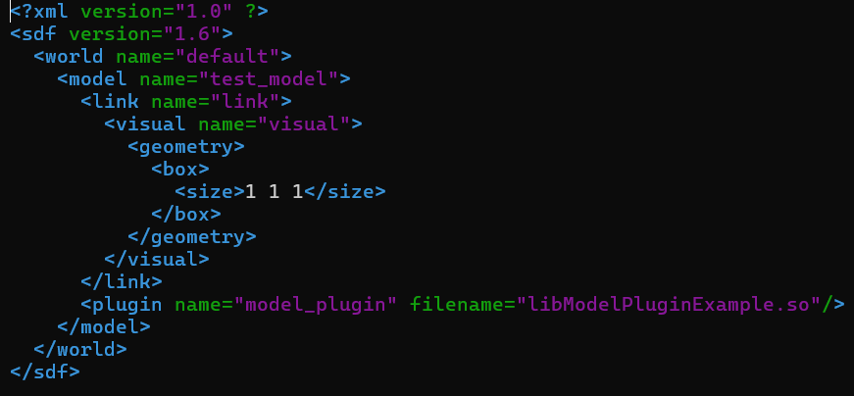

$ gazebo ~/GazeboPluginLab/sdf/model_plugin_test.sdf

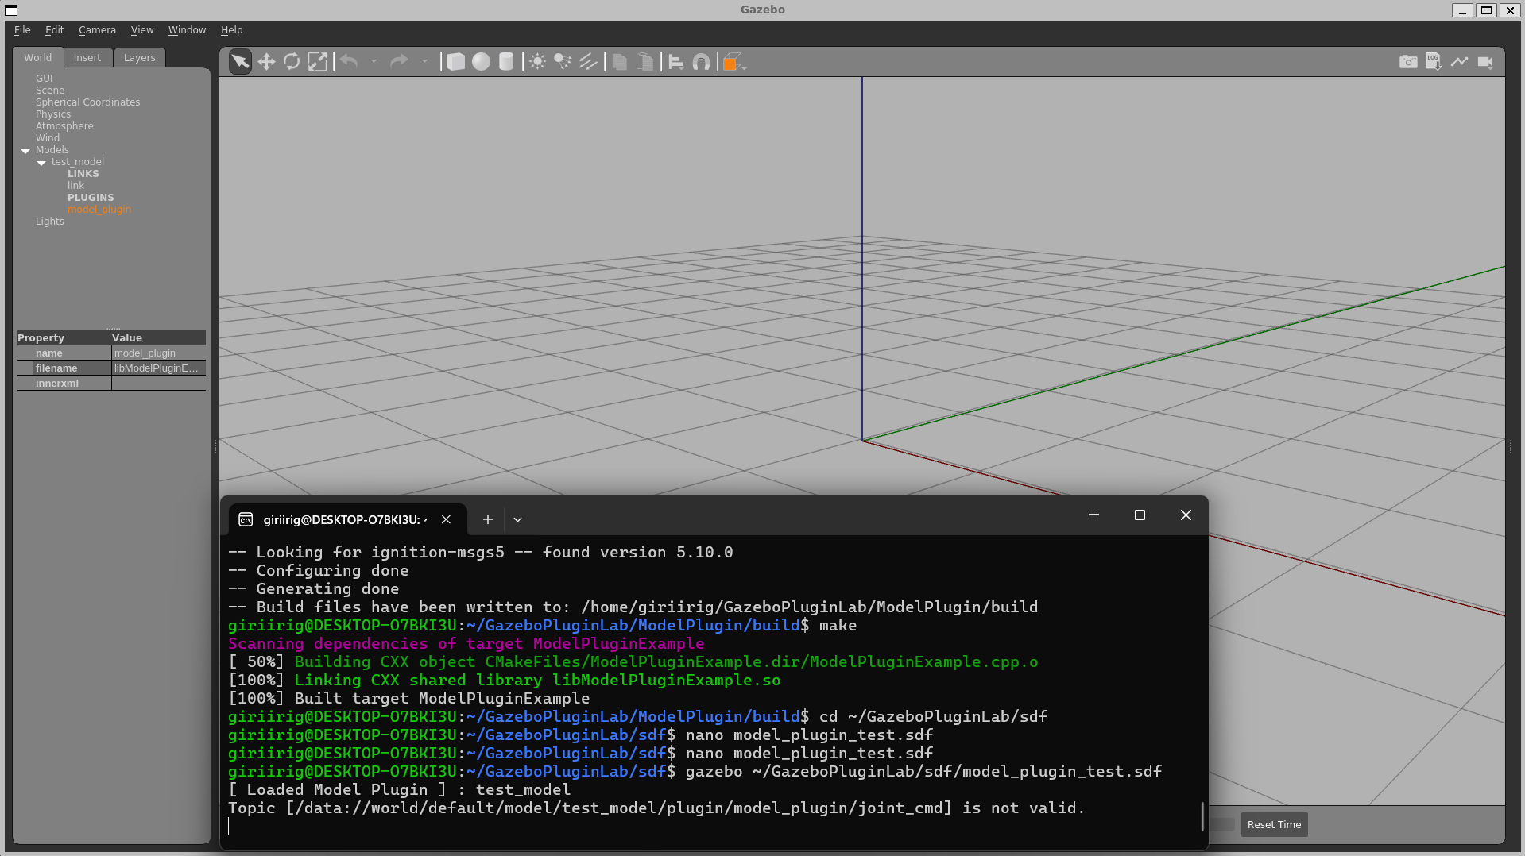

1. **Sensor Plugin**

The Sensor plugins provide customization for different sensors like cameras, lasers, LiDARs, and GPS devices. They process sensor data, customize output, and adjust sensor properties.

$ cd ~/GazeboPluginLab/SensorPlugin  
$ nano SensorPluginExample.cpp  
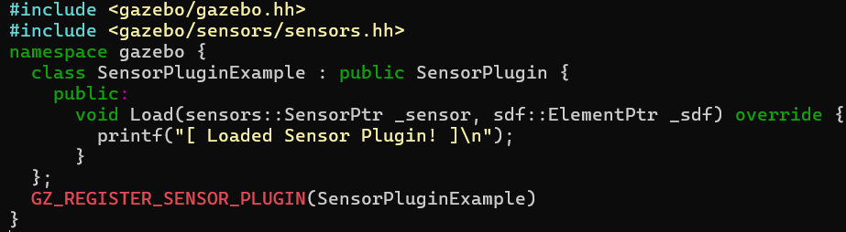  
$ nano CMakeLists.txt  
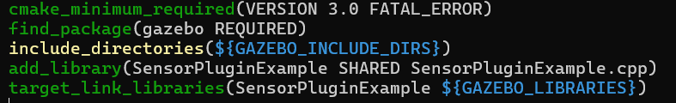

$ cd build  
$ cmake ..  
$ make

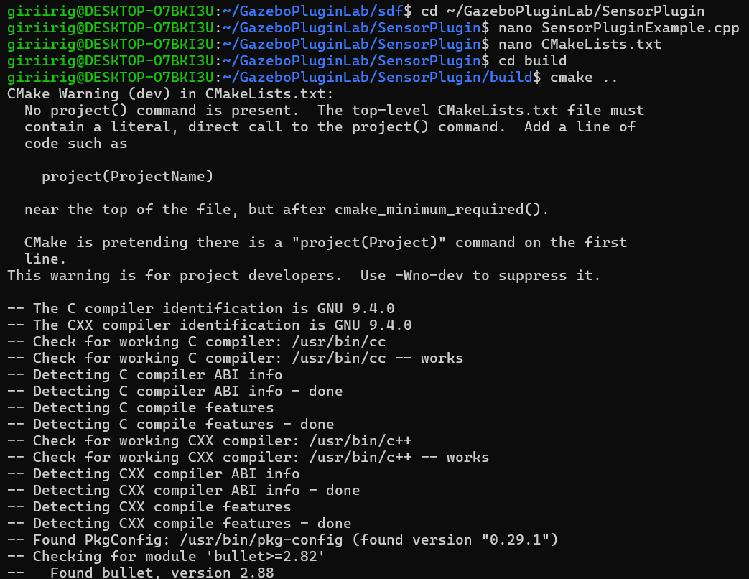

$ ***cd ~/GazeboPluginLab/sdf  
$ nano sensor_plugin_test.sdf***

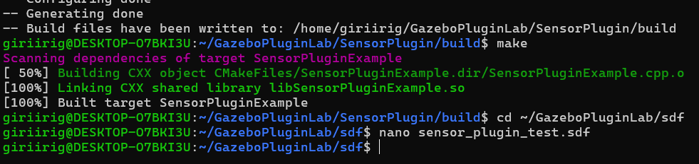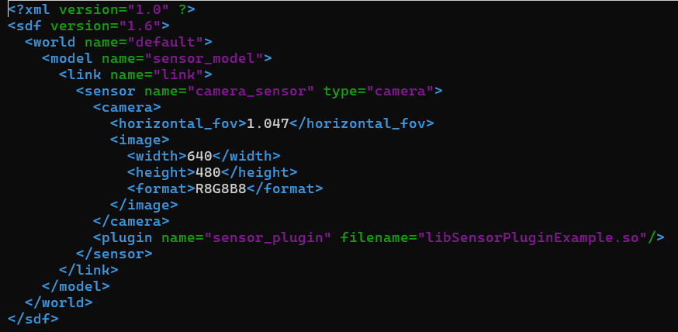$ gazebo ~/GazeboPluginLab/sdf/sensor_plugin_test.sdf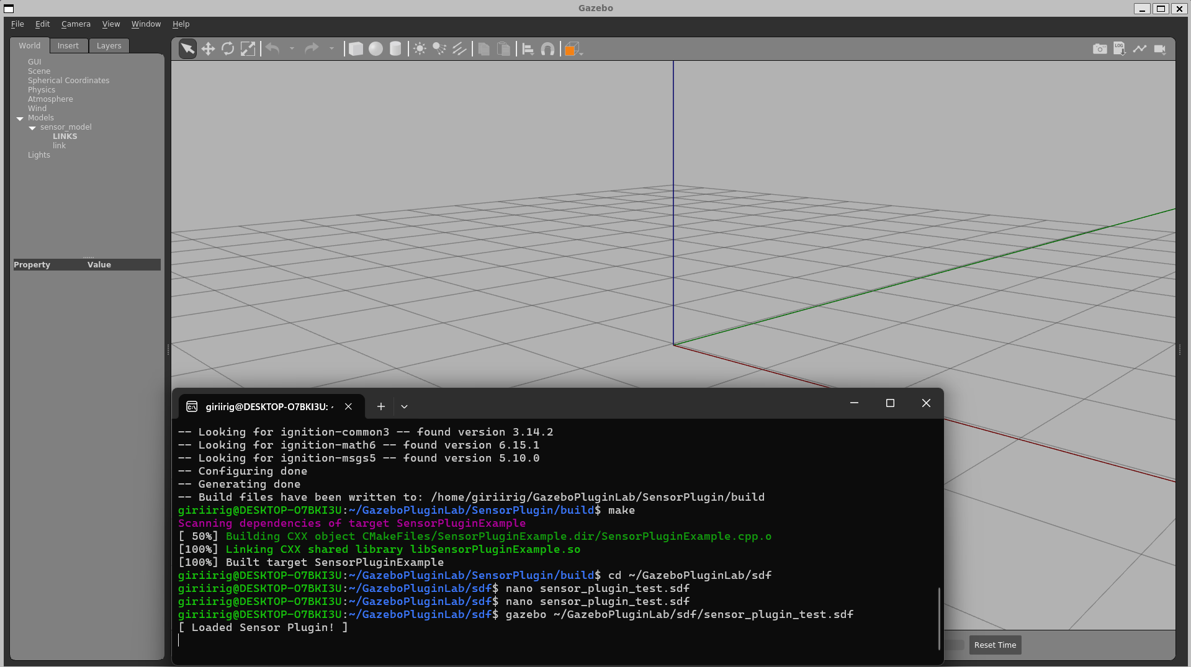

1. **System Plugin**

System plugins can control and access all aspects of the Gazebo server. They manage the simulation’s state, add event handlers, and interface with external systems, enabling system-wide control and event handling.

$ cd ~/GazeboPluginLab/SystemPlugin  
$ nano SystemPluginExample.cpp  
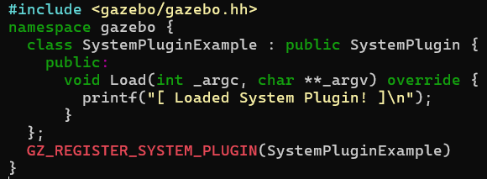  
$ nano CMakeLists.txt  
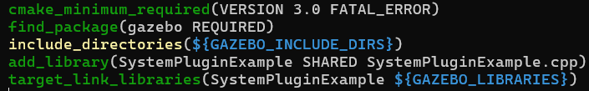  
$ cd build  
$ cmake ..  
$ make  
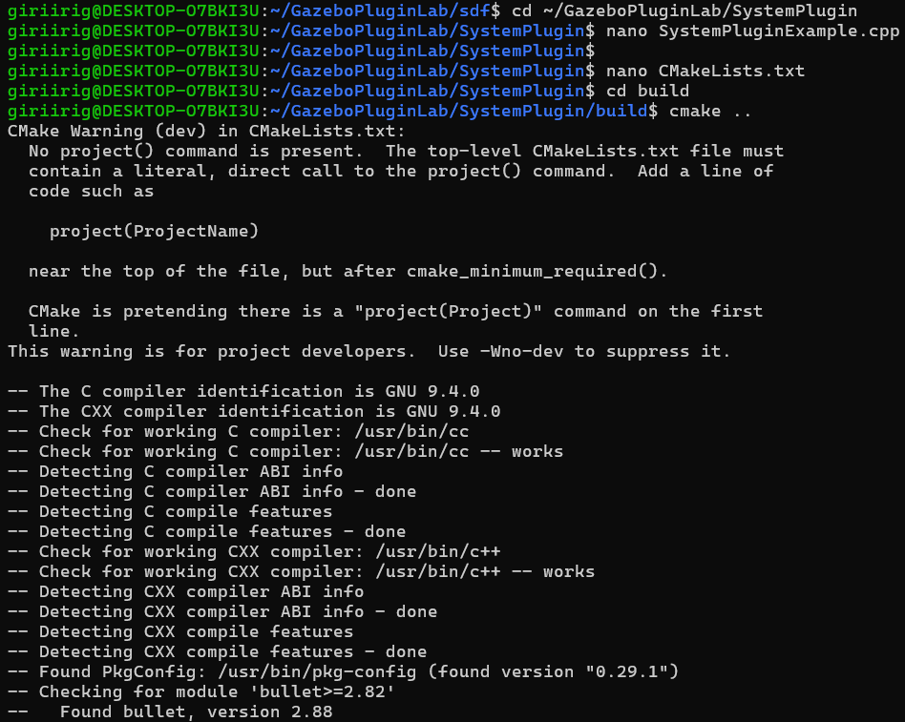

$ export GAZEBO_PLUGIN_PATH=~/GazeboPluginLab/SystemPlugin/build  
$ gazebo -s libSystemPluginExample.so  
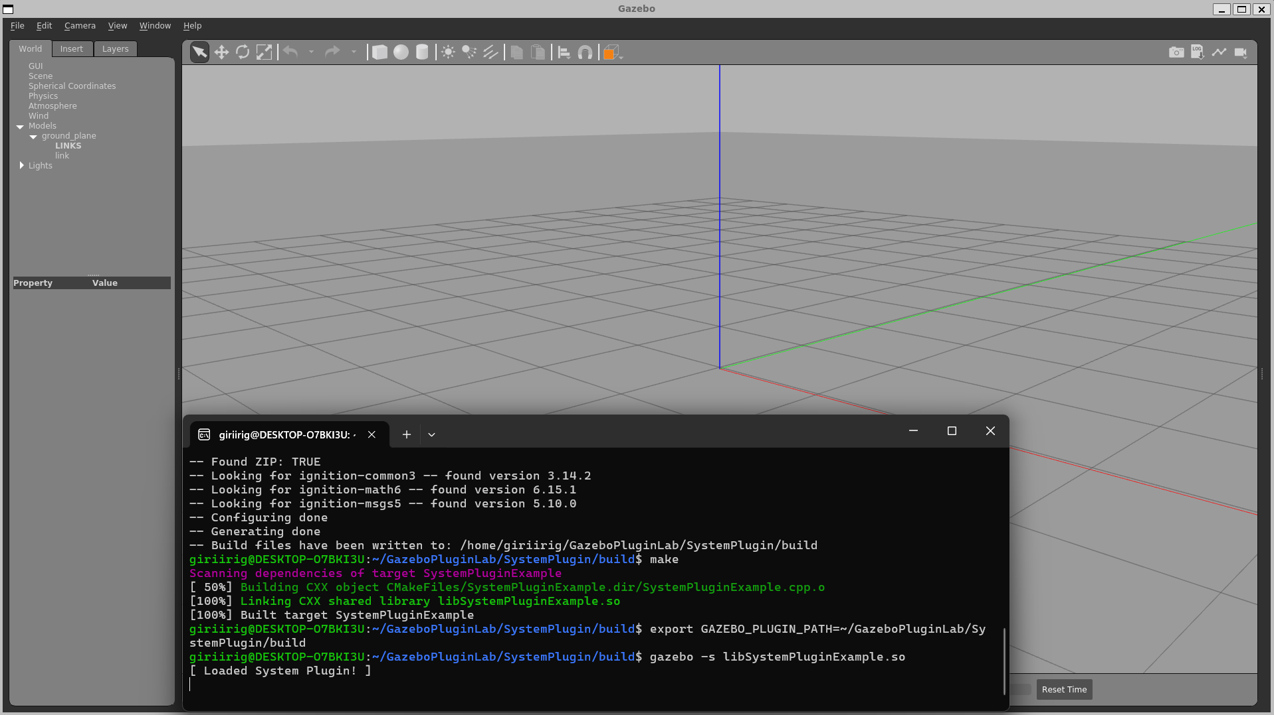

1. **Visual Plugin**

Visual plugins affect the appearance of models allowing customization of appearance and visual effects and can add effects such as color changes, transparency, and other visual properties. Visual plugins are also used to add custom rendering to models.

$ cd ~/GazeboPluginLab/VisualPlugin  
$ nano VisualPluginExample.cpp  
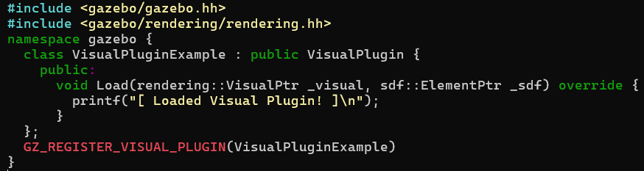$ nano CMakeLists.txt  
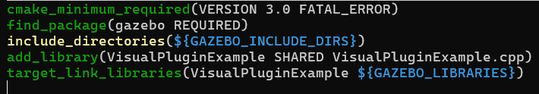

$ cd build  
$ cmake ..  
$ make

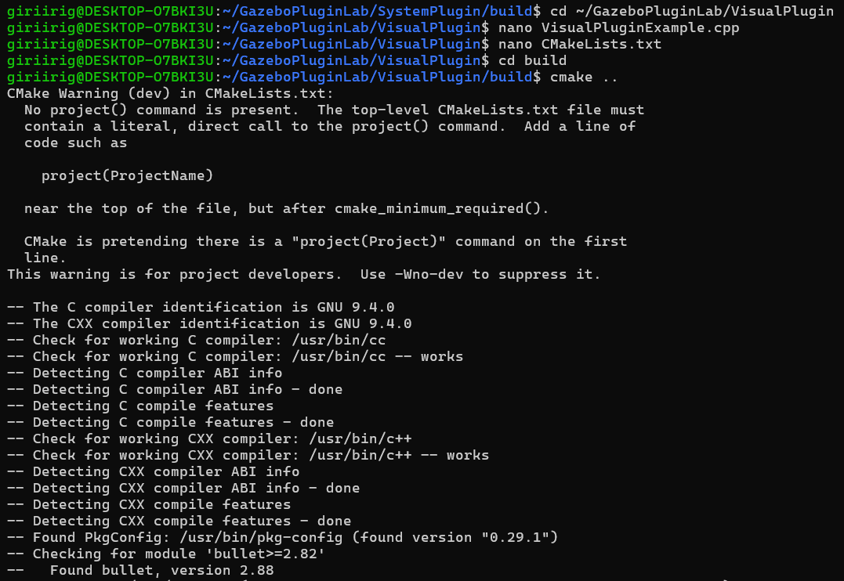

$ ***cd ~/GazeboPluginLab/sdf  
$ nano visual_plugin_test.sdf***

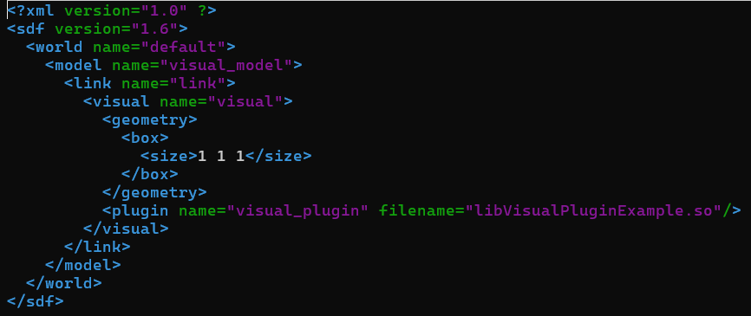

$ ***export GAZEBO_PLUGIN_PATH=~/GazeboPluginLab/VisualPlugin/build  
$ gazebo ~/GazeboPluginLab/sdf/visual_plugin_test.sdf***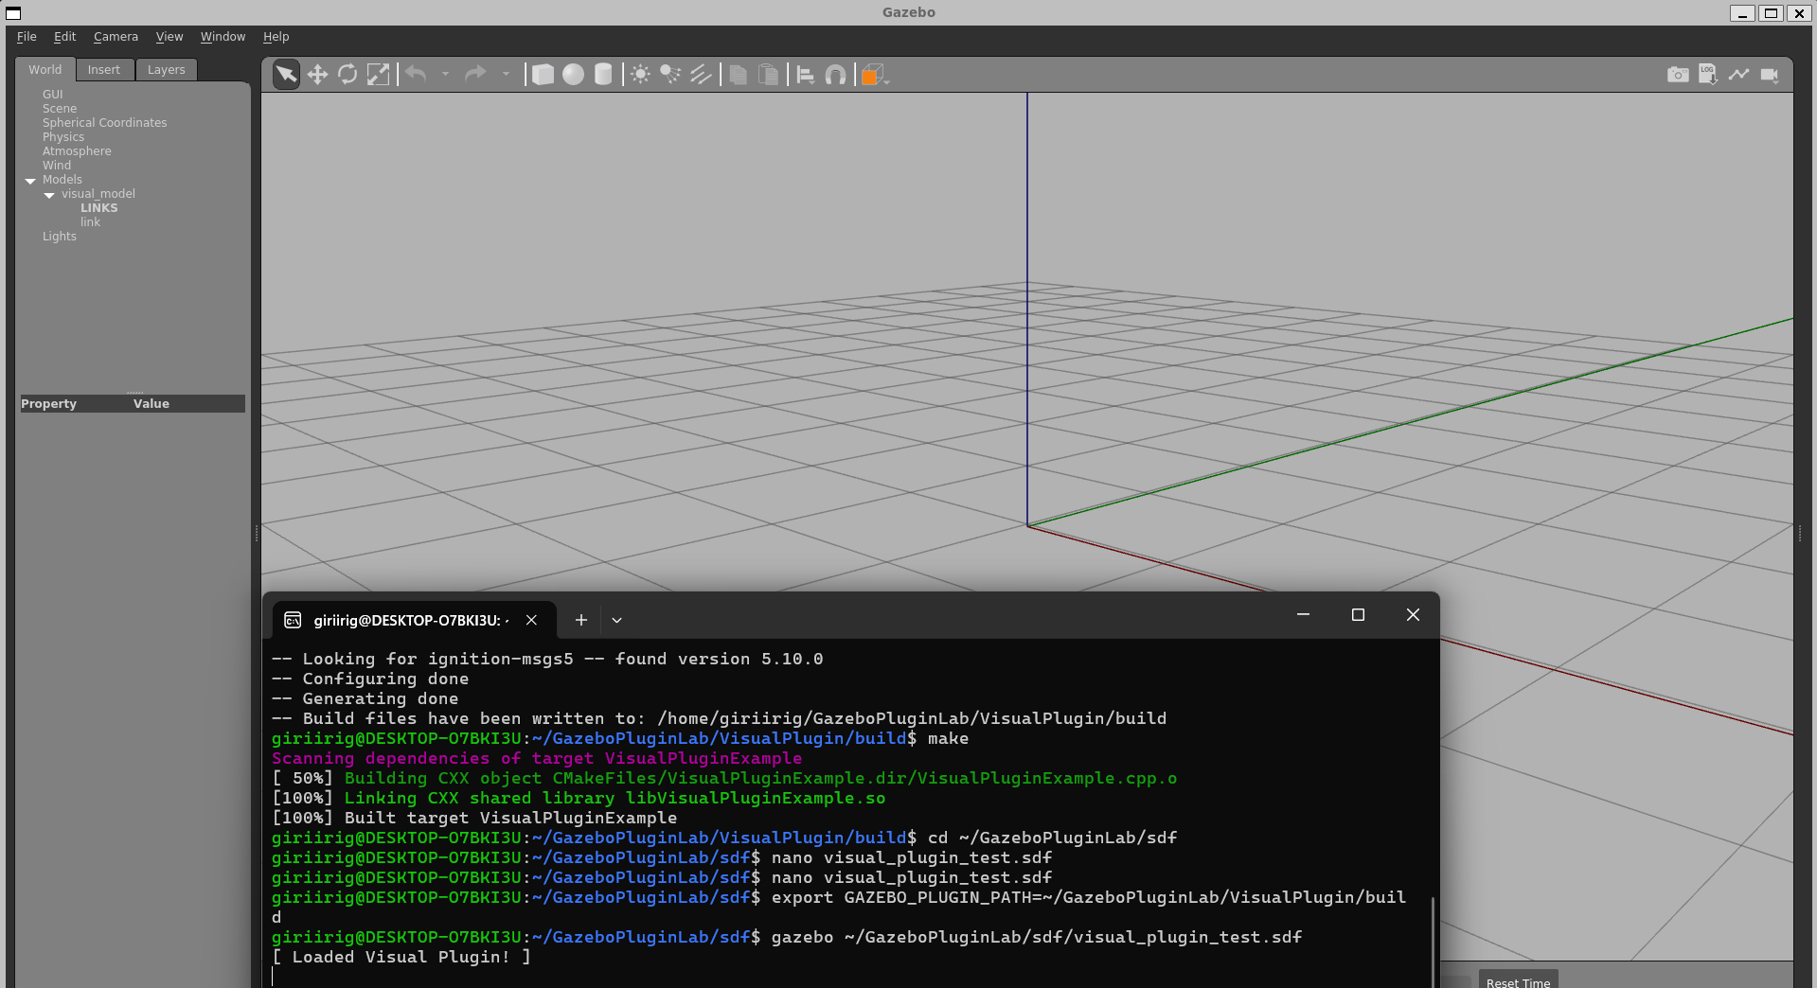

1. **GUI Plugin**

GUI plugins customize the Gazebo graphical user interface, provides additional display options and controls, allowing you to add custom panels, buttons, tools and other widgets that enhance the user experience. GUI plugins add custom UI elements or controls in Gazebo. These plugins are defined in the <gui> section of the SDF file.

$ cd ~/GazeboPluginLab/GUIPlugin  
$ nano GUIExampleSpawnWidget.hh  
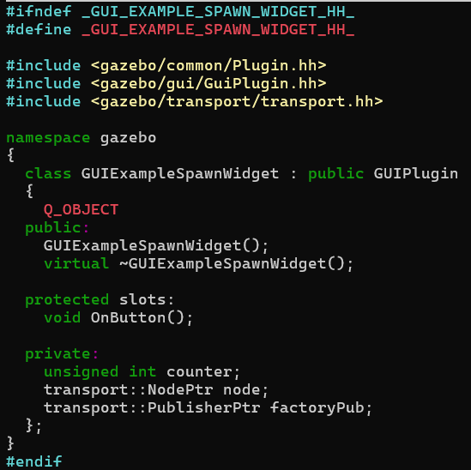

$ nano GUIExampleSpawnWidget.cpp  
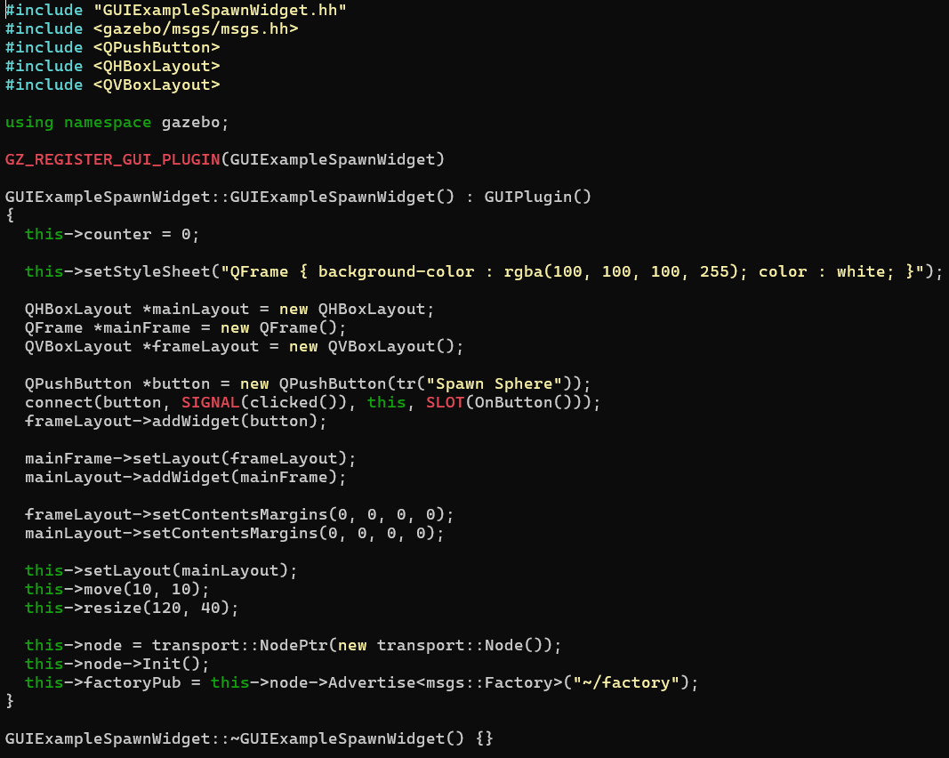  
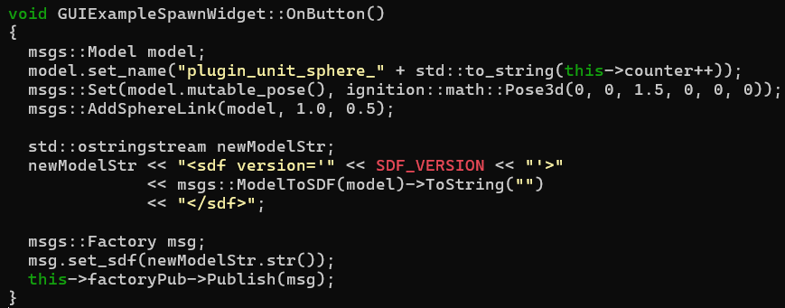  
$ nano CMakeLists.txt

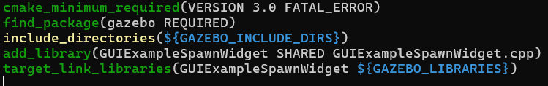

$ cd build  
$ cmake ..  
$ make  
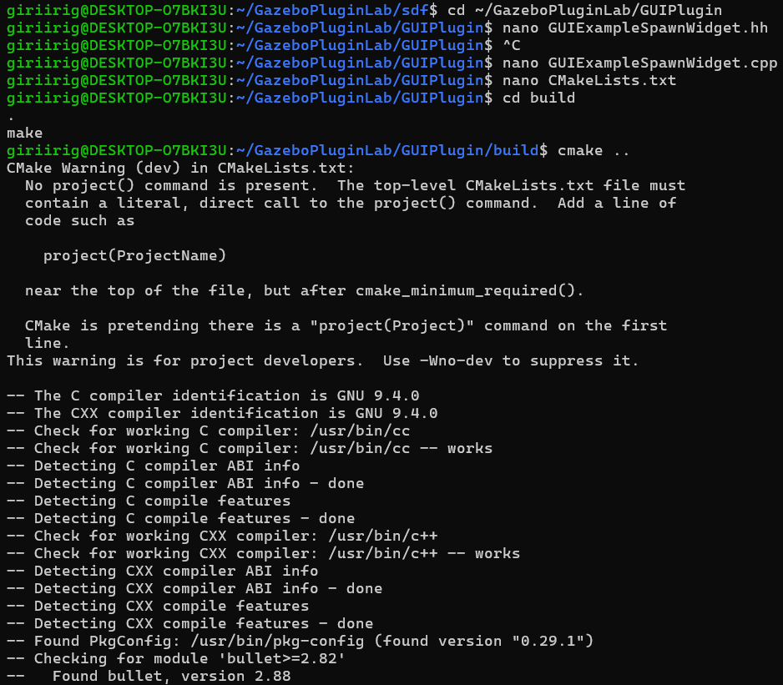  
$ ***cd ~/GazeboPluginLab/sdf  
$ nano gui_plugin_test.world***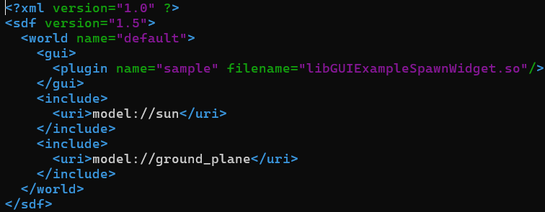

***$ export GAZEBO_PLUGIN_PATH=~/GazeboPluginLab/GUIPlugin/build  
$ gazebo ~/GazeboPluginLab/sdf/gui_plugin_test.world***

